The steel industry, a cornerstone of global infrastructure, heavily relies on coke as a reducing agent and fuel in blast furnaces. The dependence, however, presents a significant environmental challenge due to the substantial greenhouse gas emissions associated with coke production and use. A key problem lies in the high carbon footprint generated from the combustion of fossil fuels to produce coke and the subsequent CO2 emissions during the iron-making process.

## Green Hydrogen as a Solution

Green hydrogen, produced through electrolysis powered by renewable energy, offers a promising solution to decarbonize the steel industry. By replacing coke with green hydrogen, the primary chemical reaction in the blast furnace shifts from carbon-based reduction to hydrogen-based reduction, significantly reducing or even eliminating CO2 emissions. In this process, **hydrogen reacts with iron ore, producing water vapor as a byproduct instead of carbon dioxide**. This transition would not only mitigate climate change impacts but also reduce the industry's reliance on dwindling fossil fuel reserves.

## Challenges in Procurement and Storage

Despite the environmental benefits, the widespread adoption of green hydrogen in the steel industry faces substantial hurdles, particularly concerning its procurement and storage.

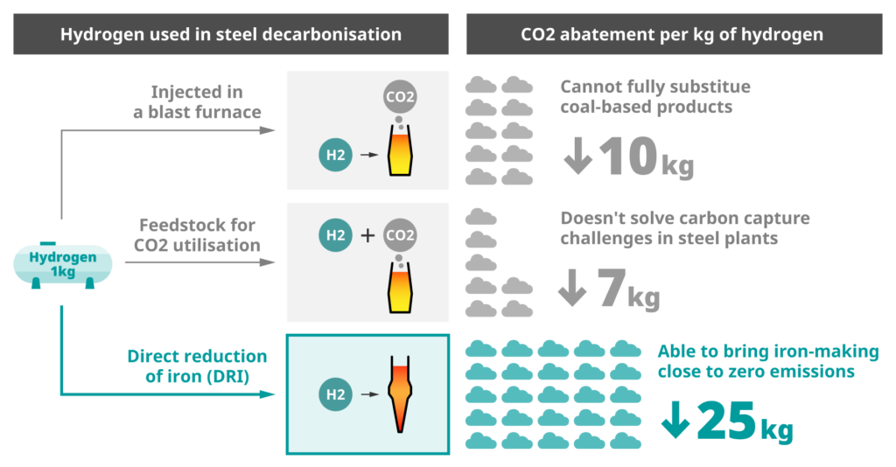

“https://share.google/images/PAkmIeUF9MuSBV8Nu”

### Procurement Difficulties

* **Scalability of Production:** The current global production capacity for green hydrogen is insufficient to meet the demands of an entire industrial sector like steel. Scaling up production requires massive investments in renewable energy infrastructure (solar, wind) and electrolyzer technology.
* **Cost:** Green hydrogen is currently more expensive to produce than traditional hydrogen or coke. The high capital expenditure for electrolysis plants and the cost of renewable electricity contribute to this price disparity, making it economically challenging for steel producers to switch.
* **Infrastructure for Transportation:** A robust infrastructure for transporting large volumes of hydrogen from production sites to steel mills is largely absent. This includes pipelines, specialized trucks, and potentially ships, all of which require significant development and investment.
* **Geographical Constraints:** The most suitable locations for large-scale green hydrogen production (e.g., areas with abundant wind or solar resources) may not always align with the existing locations of steel plants, leading to complex logistical challenges.

### Storage Difficulties

* **Low Volumetric Energy Density:** Hydrogen has a very low volumetric energy density, meaning it requires a large volume to store a significant amount of energy. This necessitates either high-pressure compression (up to 700 bar) or liquefaction (at -253°C), both of which are energy-intensive and costly processes.
* **Material Compatibility:** Hydrogen can cause embrittlement in certain materials, posing challenges for the design and maintenance of storage tanks and pipelines. Materials used must be carefully selected to ensure safety and longevity.
* **Safety Concerns:** Hydrogen is highly flammable and has a wide flammability range, requiring stringent safety protocols for its storage and handling. Leaks can pose significant risks.
* **Space Requirements:** Storing large quantities of hydrogen, especially in its gaseous or liquid form, requires considerable land area, which can be a constraint for many industrial sites.

Overcoming these procurement and storage challenges will be crucial for the successful integration of green hydrogen into the steel industry, demanding concerted efforts in technological innovation, policy support, and infrastructure development.